Fighting Adolescent Pregnancies in the wake of COVID-19 Pandemic
By Yobu Annet

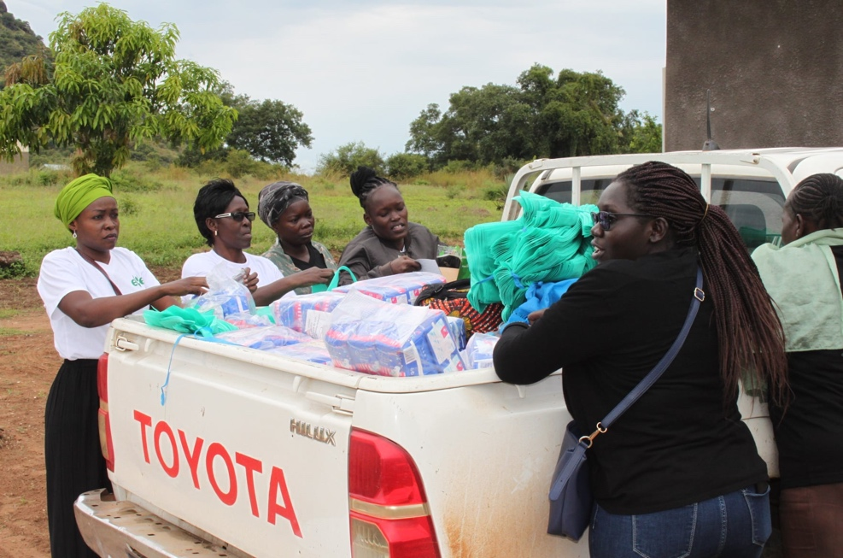
South Sudan - A number of South Sudanese girls in candidate classes have not been able to return to school after the lockdown that was imposed on schools following the outbreak of Covid-19 pandemic. At the onset of the corona virus pandemic lockdown in March 2020, the Ministry of Health in partnership with the High-level Taskforce on Covid-19 declared a lockdown that affected educational institutions- an incident that
Ms. Rita M. Lopidia the Executive Director of EVE Organization on the right takes a lead sanitary pads for Lirya girls in repackaging

has affected girls’ education. Case studies from the region and also from within the country, show that most girls became vulnerable to sexual and gender-based violence due to the outbreak of the pandemic. The report released by Support Peace Initiative Development Organization (SPIDO) a national organization in South Sudan indicates that by September 2020, about 1,500 cases of child marriages and teenage pregnancies had occurred following the imposed lock down due to Covid-19 outbreak of the pandemic.
The program officer of EVE Organization for Women Development, Nakande’ba says the huge number of schools drop out of girls is a threat to women’s efforts of grooming the young women and girls as a strategy to take up the 35% representation enshrined in the R-ARCSS. “There is a generational academic gap that exists among the women of South Sudan due to the successive civil wars”, she said. “As such, a few women may qualify for the available leadership opportunities”.
The Agreement for the Resolution of the Conflict in South Sudan (R-ARCSS) that was signed in 2018 provides for the 35% representation of women at all levels of leadership. However, the effects of COVID-19 pandemic on school girls is an appalling situation that has increasingly widened the journey to professionalism.
EVE Organization for Women Development that has been empowering and preparing potential young women leaders to change the narrative came up with a distribution activity to help girls under-going inevitable circumstances address their issues without turning to men who see no value in the girls’ efforts to have a dignified destiny.
The organization provided dignity kits to vulnerable girls in four villages of Juba County. About 750 girls and young women aged between 13 and 30 walked home with packets of sanitary-pads and soap enough for three months. Girls and young women who benefited from the distribution of the dignity kits were identified from the communities of Rokon, Lirya, Hai-Referendum and Hai-Jerusalem.
According to the executive director of EVE Organization for Women Development Ms. Rita M. Lopidia, this activity was necessary in order to reduce the impact of COVID-19 pandemic on menstrual hygiene among young girls. “Lack of financial support from parents resulting from redundancy due to the lockdown and the skyrocketing prices of sanitary pads as a result of the economic melt-down has caused serious risks to girls and women”, she mentioned. This condition has escalated the number of girls who became victims of early pregnancies and got into marriage during this period hence missing the opportunity of furthering their studies.
She further says, giving the young girls dignity kits reduces their exposure to alternative ways of acquiring sanitary kits that would have exposed them to COVID-19, HIV/AIDS, Sexually Transmitted Diseases and unwanted pregnancies.
Mama Madeline a women leader in the community of Lirya says that the scarcity of essential health services due to the lockdown has caused many young women and girls to be traumatized. She appealed for the continuation of the distribution of the sanitary pads after every three months.
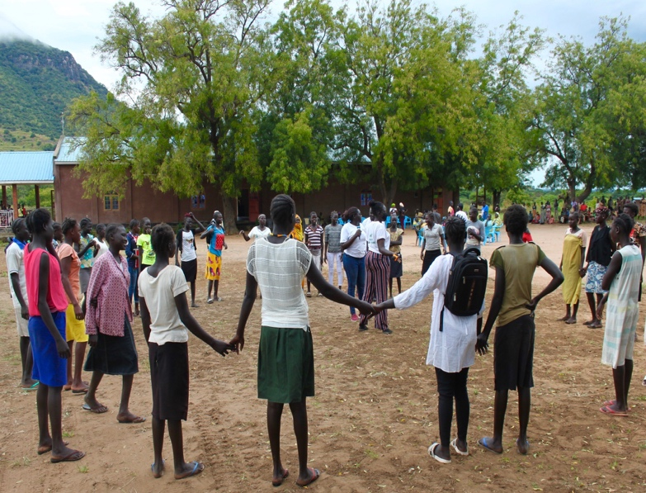
A team of Eve’s staff led by Suzan Paul discussed with the girls and young women on how to overcome increased stigma, shaming and harmful practices associated with menstruation during the COVID-19 pandemic. The adolescent girls were encouraged to take care, maintain both social distance, wash hands and maintain healthy menstrual hygiene.
The local chief Camerino of Lirya Payam expressed concerns of the reduced number of girls that may return to school since idleness has caused many girls to lose focus from education.
According to him, the long period out of school has caused the boys to venture into searching for greener pastures outside their locality, while a number of girls have been married off. “We are concerned and most likely to lose a full generation as COVID-19 has reduced their academic strength”.
In a consultative meeting with the community leaders of Hai-Referendum an area which also benefited from the services, Sultan Muhamed Babala Mayar disclosed that some girls joined bad groups, hence having no hopes of going back to school once schools re-open.
Awetch commented that idleness has caused many energetic young people to indulge into out-lawed activities which have resulted into dire consequences for the youth. “Some young girls are seen lingering around on the streets seeking for alternative ways of getting money to meet their needs”, he said.

